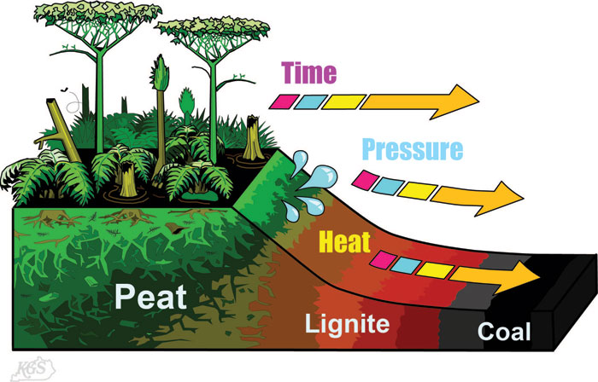
How is Coal Formed?
Coal is formed when peat is altered physically and chemically. This process is called "coalification." During coalification, peat undergoes several changes as a result of bacterial decay, compaction, heat, and time. Peat deposits are quite varied and contain everything from pristine plant parts (roots, bark, spores, etc.) to decayed plants, decay products, and even charcoal if the peat caught fire during accumulation. Peat deposits typically form in a waterlogged environment where plant debris accumulated; peat bogs and peat swamps are examples. In such an environment, the accumulation of plant debris exceeds the rate of bacterial decay of the debris. The bacterial decay rate is reduced because the available oxygen in organic-rich water is completely used up by the decaying process. Anaerobic (without oxygen) decay is much slower than aerobic decay.
For the peat to become coal, it must be buried by sediment. Burial compacts the peat and, consequently, much water is squeezed out during the first stages of burial. Continued burial and the addition of heat and time cause the complex hydrocarbon compounds in the peat to break down and alter in a variety of ways. The gaseous alteration products (methane is one) are typically expelled from the deposit, and the deposit becomes more and more carbon-rich as the other elements disperse. The stages of this trend proceed from plant debris through peat, lignite, sub-bituminous coal, bituminous coal, anthracite coal, to graphite (a pure carbon mineral).
Because of the amount of squeezing and water loss that accompanies the compaction of peat after burial, it is estimated that it took 10 vertical feet of original peat material to produce 1 vertical foot of bituminous coal in eastern and western Kentucky. The peat to coal ratio is variable and dependent on the original type of peat the coal came from and the rank of the coal.

