History of DDT
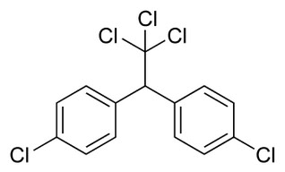
DDT Definition
· DDT: dichlorodiphenyltrichloroethane, a synthetic organic compound introduced in the 1940s and used as an insecticide. Like other chlorinated aromatic hydrocarbons, DDT tends to persist in the environment and become concentrated in animals at the head of the food chain. Its use is now banned in many countries

Why DDT Seemed Ideal
· Broad spectrum pesticide with a low toxicity toward mammals
· Did not break down rapidly in nature – did not have to be reapplied often
· Not soluble so it could not be washed out by rain
· Cheap to manufacture with readily available chemicals
· Extremely effective at killing mosquitoes and farm pests
Brief History
· First synthesized in 1874 by Dr. Paul Muller
o Won Nobel Prize in medicine for his discovery
· Put into use as a pesticide in 1939
o Used in World War II to combat vector-borne diseases such as typhus and malaria
· In 1945, DDT was used by farmers to control pests such as:
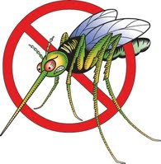
o various potato beetles
o coddling moths
o corn earworms
o cotton bollworms
o tobacco budworms
· 1955 – the World Health Organization sponsors a worldwide malaria control program heavily leaning on DDT
· After about a decade of use, many insects began forming resistances to DDT and toxicity was showing up in fish
· 1969 – attempt to eradicating malaria was stopped and rather focused on controlling the disease instead
· Environmental Defense Fund notices pattern of bird deaths in connection with DDT after reading Rachel Carson’s Silent Spring
· The EPA held several hearings between 1971 and 1972 concerning the banning of DDT after Norway and Sweden’s ban in 1970
· DDT was banned in June of 1972 due to increasing environmental and health concerns
o There is a clause stating that DDT is still permitted for public health uses under certain conditions
§ There have been some cases of use in the United States to help control Bubonic Plague
· Although the United States no longer uses DDT, some developing countries use it to control malaria because it is so cost effective
· World Health Organization estimates that 25 million lives were saved during its use
DDT in Borneo
· In 1950, the World Health Organization started spraying DDT in Borneo to help prevent the spread of Malaria
· Caused a great disruption in the food chain, eventually leading to a plague
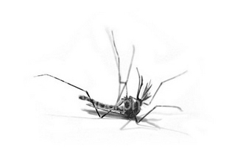DDT is sprayed and kills almost all mosquitoes

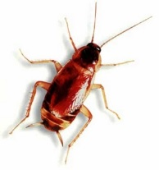The leftover DDT that was deposited on the ground was consumed and stored in roaches
Lizards consumed the roaches, also becoming infected with DDT and dramatically slowing down their motor skills. The slow lizards were now more accessible to cats, who readily ate them
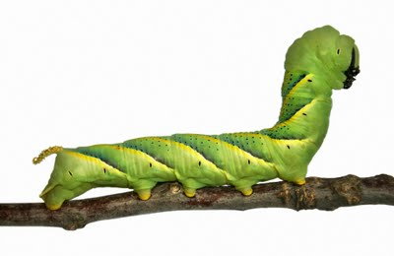Caterpillars who had previously been prey to the lizards now thrived and fed off of people’s homes
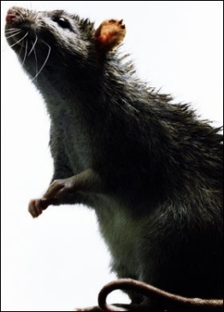
Rats begin to thrive due to the absence of their predators, cats, and begin to spread plague and typhoid fever throughout Borneo

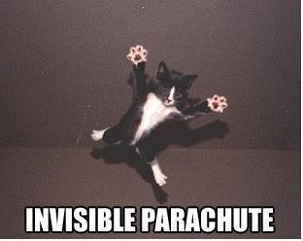
A state of emergency was declared and cats were airdropped into the country by parachute to control the rats once again

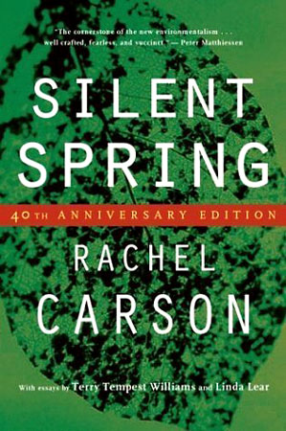
(EPA) In spite of scientists warning the public about DDT it was Rachel Carson's 1962 novel Silent Spring that further reinforced and made the public aware of the dangers of DDT
- she attacked the claims made by the chemical companies that the public had accepted
- documented the effects of DDT on wildlife

- Following her publication many nongovermental organizations developed and sought to obtain a greater underestanding of DDT - pressured the government to take action

- (Hort) her work was also apparent on the international scale where in France, Germany, and other countries all had increased environmental legislation.
- however supporters of pesticide usage argue that Carson's view was bias and did not address the benefits of pesticide usage
- also argue that farm yields would be greatly reduced without pesticides
- (Classwebs) some even argued that "the world would not be able to feed itself without pesticides"

-(Classwebs) An executive of the American Cyanamid Company explained, "if man were to faithfully follow the teachings of Miss Carson, we would return to the Dark Ages, and the insect sand diseases and vermin would once again inherit the earth,

-another result: pesticide companies take on a more aggressive role of informing the public about the benefits of pesticides
- (Hort) was the cause for the funding of the 1967 Environmental Defense Fund--> would later ban DDT
- many cite the banning of DDT in America as a direct effect of Silent Spring
- As Al Gore once said "Silent Spring can properly be seen as the beginning of the modern environmental movement"- (Uneco)

-now supporters of DDT argue that alternatives to DDT would be more destrimental for humans than current DDT, and that as if now, DDT poses no immediate epidemic risk

- those against DDT argue that there are other unknown conseuqences to DDT, and most commonly citing then toxic chemicals that would be collected in the food chain

- there are over 70,000 synthetic chemicals and only 2% of them have been tested for the potential to cause cancer. Between 1940 and 2009 the production of these chemicals had increased 100 fold

