APES Eco-Column Lab Name____________________
Purpose: This lab will provide opportunities to investigate the components of different ecosystems, in miniature. The conditions required for the sustainability of the ecosystems, and the interconnections between them will be studied. This is a long-term study that will not be completed until the end of the semester.

Materials (to be used on day 1 of the lab)
- 1 gallon square clear plastic water bottles (3) with the labels removed completely*
- bottle caps (2)*
- dissecting needle
- Tea candle
- Scissors
- Razor blade
- soil
  - sand
  - gravel

Materials (to be used after the column has reached preliminary equilibrium)
  - seeds
  - ruler
  - water quality tests
  - nitite/nitrate test strips
- selected aquatic plants (anacharis, elodea, duckweed, hornwort, green hedge, ludwigia, etc.)*
- terrestrial fauna (pillbugs, earthworms, earwigs, fruit flies, etc.)*
- aquatic fauna (small fish, small aquatic snails, etc.)*

* Students will bring these materials to school.

Procedure
- Soak 3 square bottles in warm water to remove labels
- Use a razor blade and then scissors to cut your bottles to look like this:

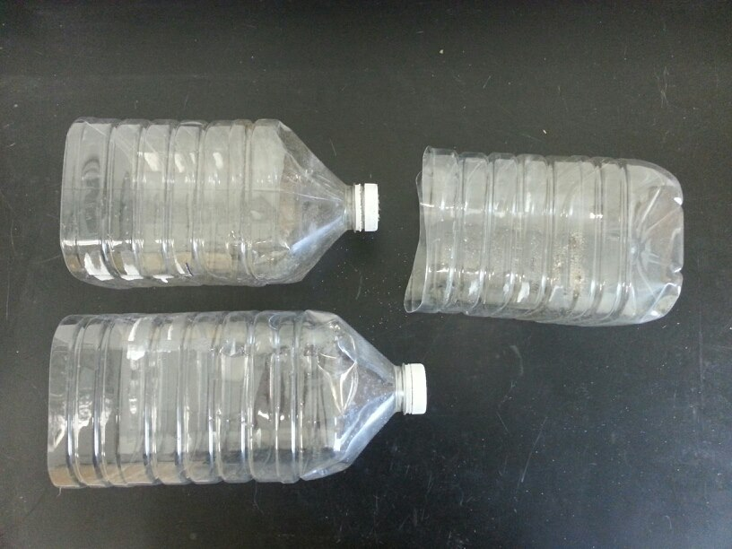

- Assemble your bottles to make sure they nest into one another like this:
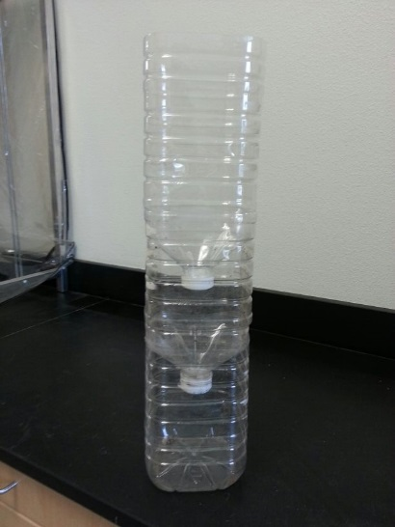

- Next, use a tea candle and a dissection probe to poke holes in 2 lids. Heat up the tip of the probe with the candle and then melt holes with the probe. You need about 10 holes per lid. Test to make sure water drains through. Don’t make them too small or they will clog easily with silt, but don’t make them too big or silt and/or sand will leak through the holes.
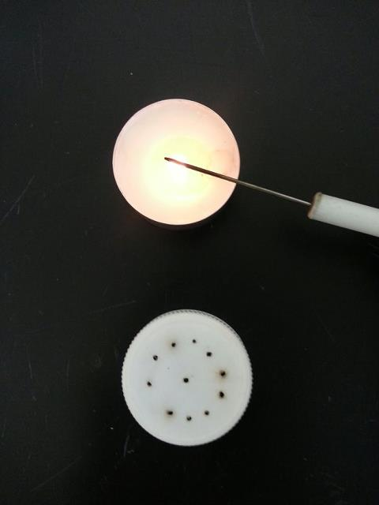

- Reassemble the three bottles into a column (like picture #2) and test to make sure water drains through.
- Take one of your cut off bottoms that’s about 3-4 cm. tall. Use the candle and dissection probe to poke 10-12 holes in it. Set this sprinkler aside, you will need this on day 2.
- Fill your top bottle (terrestrial chamber) with:
  - 3-4 centimeters of gravel on the bottom to promote proper drainage
  - Potting soil up to about halfway full
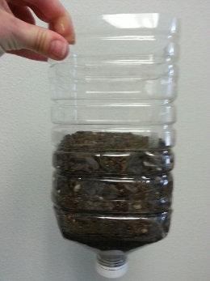

  - Fill this chamber with water, place over a large plastic beaker and check to make sure it drains properly. Add more potting soil as water will compact the soil and lower the level.
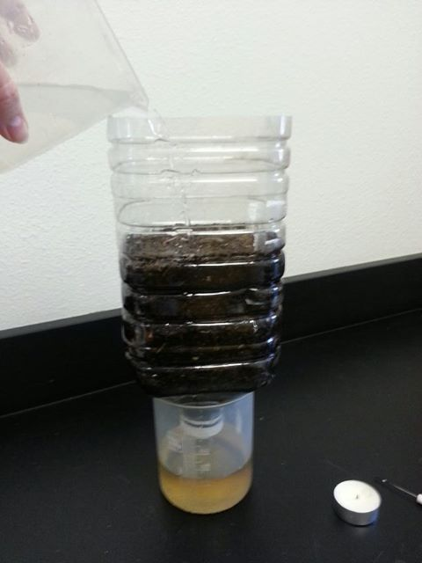
  - Drain 3-4 times with tap water. Often, an eco-column will drain properly the first couple of times, then clog with silt.

    - If it clogs with silt, carefully unscrew the lid so that you relieve the pressure without taking the lid off completely. The water should drain out. Then, set the chamber on its side and take off the lid. Rinse with water to clear the silt and then make your holes slightly larger using the candle and dissection probe.

  - Replace the lid and check the drainage several times again. If it clogs again, repeat the previous step.
- Fill your middle chamber (filter chamber) with
  - 3-4 cm of gravel on bottom
  - 10-12 cm of sand on top
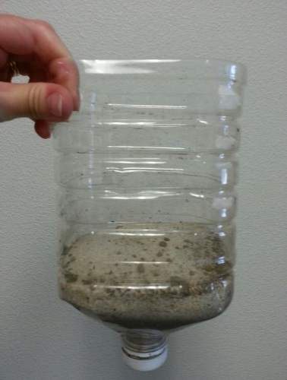
  - Drain 2-3 times the same way you did the terrestrial chamber. If the chamber clogs, follow the same steps as in the terrestrial chamber to unclog (6.d.i).

- When you have drained each chamber separately several times, reassemble your eco-column:
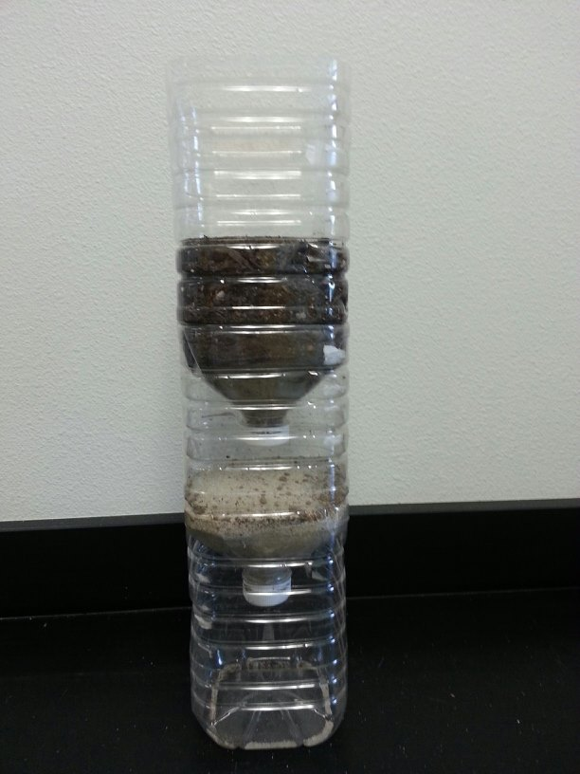

- Fill the eco-column with tap water and let drain through all the chambers to the bottom overnight.

Day 2
- The next day, separate the 3 chambers. Drain the terrestrial and filter chambers separately into large beakers 5-6 times. Check for clogs and unclog if necessary.
- When all chambers are draining properly, it is time to plant seeds in your terrestrial chamber.
  - Add 3 mung bean seeds 1 cm deep.
  - Add 3 other seeds (your choice) 1 cm deep.
- Make your first data entry using this template. You will fill in the date, day #, additions and observations today.
Date ____________________ Day #__________
Adjustments to Eco-Column (additions, subtractions etc.)
Measurements:
Dissolved Oxygen:
pH:
Temperature:
Nitite/Nitrate:
Mung Bean height:
Other plant height:
Aquatic plant length:
Other measurements:
Observations: What changes do you see? What else
is happening?
- Keep comprehensive records of all work on the ecocolumn. You will make data charts and graphs. Do not lose your data sheets for your lab. You will need it all semester! Each day we take data, you will make another chart. Some students buy a small notebook just for eco-column data.
- Assemble your column and place the sprinkler you made in step #5 on top. Fill with water and allow to sprinkle your terrestrial chamber. Let drain overnight.
After approximately 1 week:
- On a daily basis, empty your aquatic chamber and fill up the top sprinkler. Not only are you keeping your terrestrial chamber moist, but you are continuing to drain your eco-column.
- When the seeds germinate, measure the height using a ruler (mm or cm) and create a new data chart.
- Add detritivores to your terrestrial chamber. Find some leaves from the schoolyard, tear up and place on top of your soil. This provides food and hiding places for your insects. You must find at least 2 different insects: Earthworms, crickets, pill bugs (aka rolly pollies), beatles, pinscher bugs etc. I do not recommend caterpillars or grasshoppers as they will eat all your seedlings! If you are too wimpy to find bugs, you can buy worms where you buy fish bait and crickets at the pet store.
Create a new data chart showing your additions.
After approximately 2 weeks:
- When the water drains clear or almost clear, it is time to set up your aquatic chamber.
- Empty the dirty water into the sink. Fill your aquatic chamber with about 2 cm of gravel. Rinse with tap water several times (without letting the gravel fall into the sink and clog the drain!) to clean it. This is very important as gravel is typically dirty and you don’t want to dirty your water.
- Fill with 800-1000 ml of distilled water.
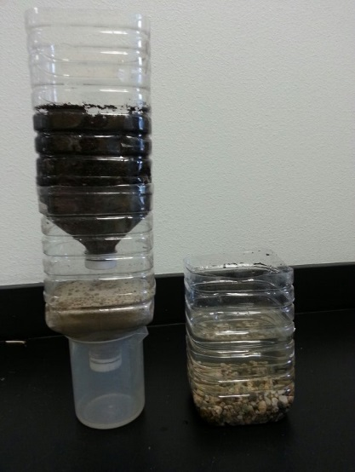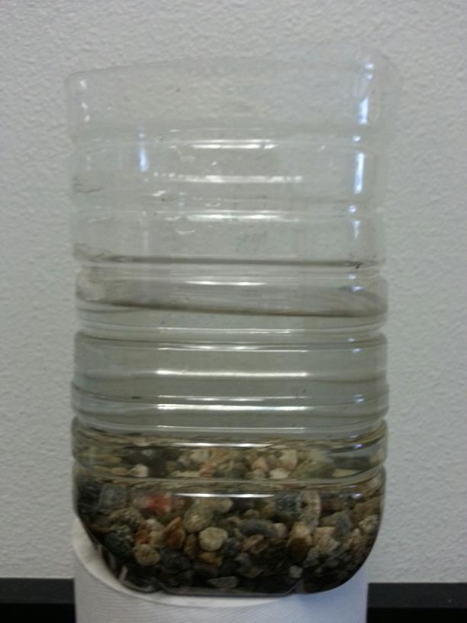

- Take water quality readings.
- Take the following readings—Make sure you ALWAYS record units!
  - Temperature in cm (the temperature will be room temperature, but if this was a steam, the temperature is very important, but dissolved oxygen concentration is dependent to temperature)
  - Dissolved oxygen in mg/l
  - pH (no unit)
  - Nitrite/Nitrates. Read the directions on the bottle to dip the test strip into your aquatic chamber. Then read the strip and record in ppm.
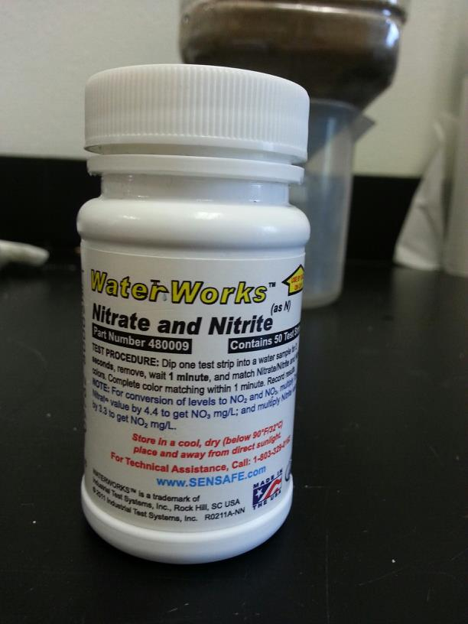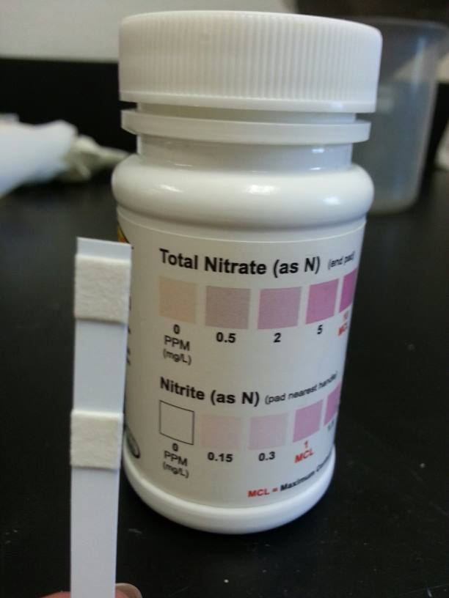
(Today, we will take one reading for the distilled water and use it for all the group’s data since the distilled water comes from one source. This saves us money as the strips cost $20/bottle. Everyone’s eco-column will be different after today, so you will take readings of your own water later)
- After your water quality readings, take an aquatic plant, measure it in cm and record your data. Then place in the water anchoring it in the gravel.
- Reassemble your column and water with tap water just a little bit from the top. From this point, you only want to water just enough to moisten the soil and drip a VERY SMALL amount into the aquatic chamber. This helps keep the water clean, but allows some particles to drip through which is important for the aquatic ecosystem.
After 2-3 days
- Take water quality readings and record data.
- Add a fish—you can bring your own fish or use one of my goldfish. If you buy a fish, I recommend a guppy, because they can tolerate cold, slightly dirty water. They can also go a long time without food. DO NOT buy Chinese Fighting Fish as they will see fish in other chambers and become stressed. We will never feed the fish. In nature, herbivorous fish eat algae, particles and aquatic plants. Your fish will survive on these items.
- Your eco-column can only handle 1 goldfish or MAYBE 2 guppies before it runs out of dissolved oxygen and/or nitrates from fish waste get too high.
For the next several weeks
- Take data readings about once a week. Make sure you save all your data.
- If your fish dies, bury it in the terrestrial chamber. Wait a few days until your dissovled oxygen readings are higher than 3 mg/l and then add a new fish.
At the end of the lab
- Place fish (if still alive) back into the class aquarium or take home.
- Empty chambers in the planters outside.
- Take chambers to the recycle bin in the auto compound (white dumpsters).

