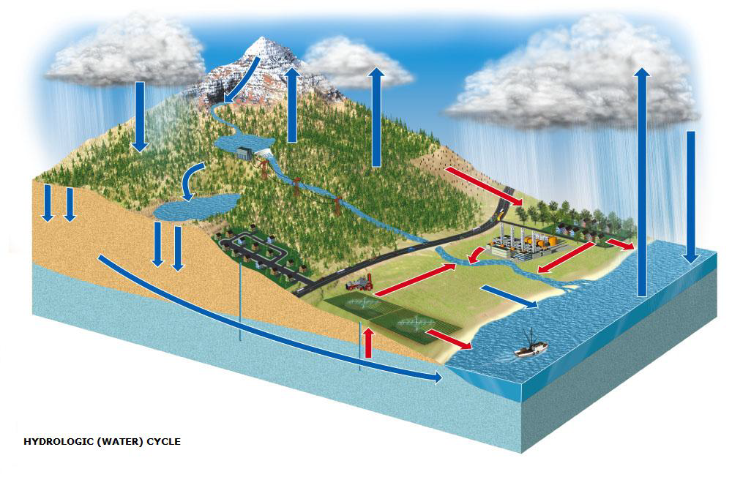
RESERVOIRS
WATER CYCLE
A.
B.
C.
D.
E.
HUMAN EFFECTS
*
*
*
*

PROCESSES
1.
2.
3.
4.
5.
6.
7.
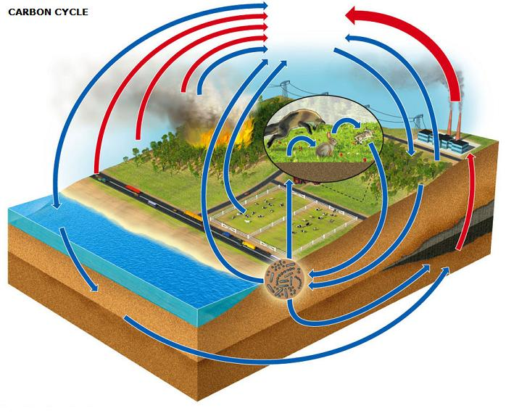
RESERVOIRS
A.
B.
C.
D.
E.

HUMAN EFFECTS
*
*
*
*

PROCESSES
1.
2.
3.
4.
5.
6A.
6B.
6C.

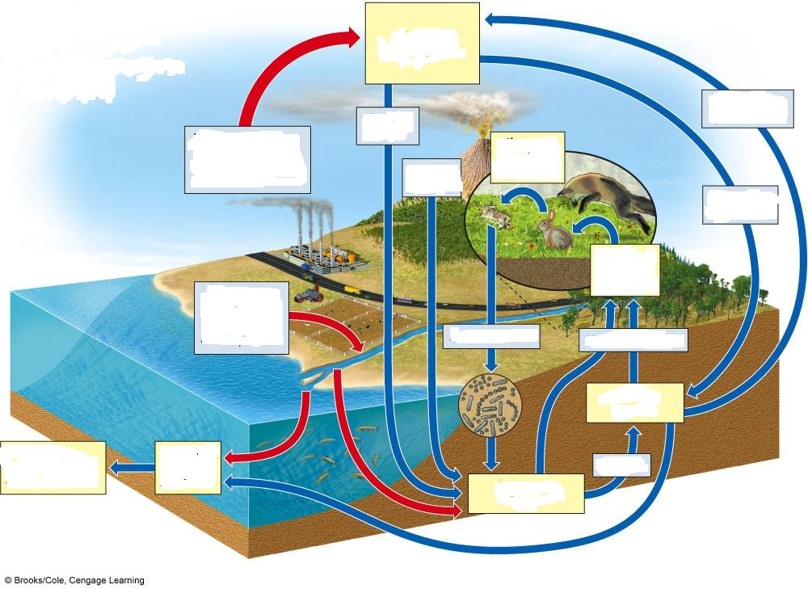
NITROGEN CYCLE
RESERVOIRS
A.
B.
C.
D.

HUMAN EFFECTS
*
*
*

PROCESSES
1.
2.
3.
4.
5.
6.
7.
8.

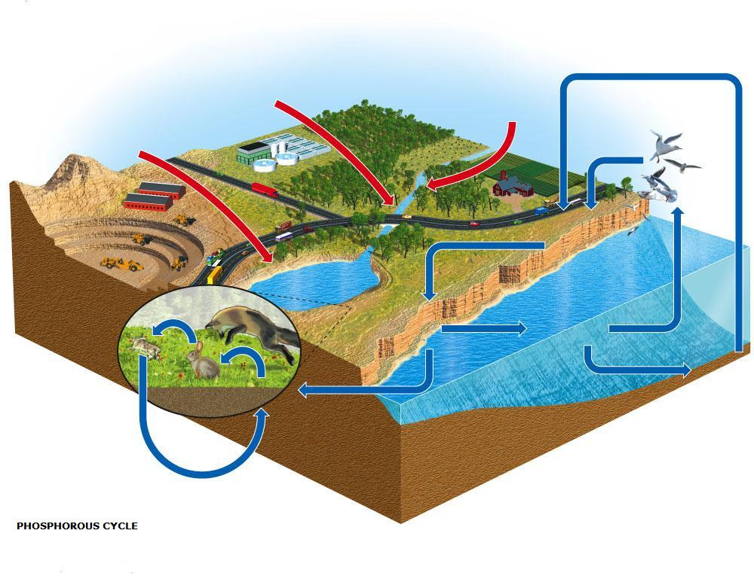
RESERVOIRS
PHOSPHOROUS CYCLE
A.
B.
C.
D.
E.
F.

PROCESSES
1.
2.
3.

HUMAN EFFECTS
*
*
*

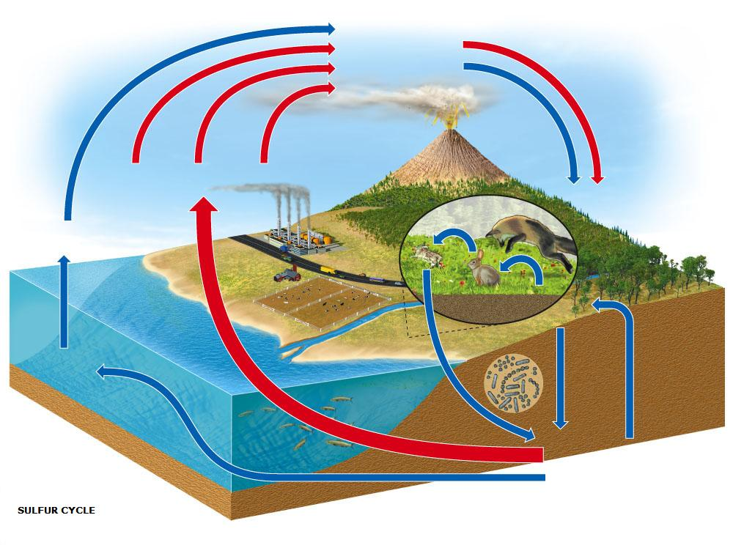
RESERVOIRS
SULFUR CYCLE
A.
B.
C.
D.
E.

HUMAN EFFECTS
*
*
*
*
*

PROCESSES
1A.
1B.
1C.
2.
3.
4.
5.
6.

