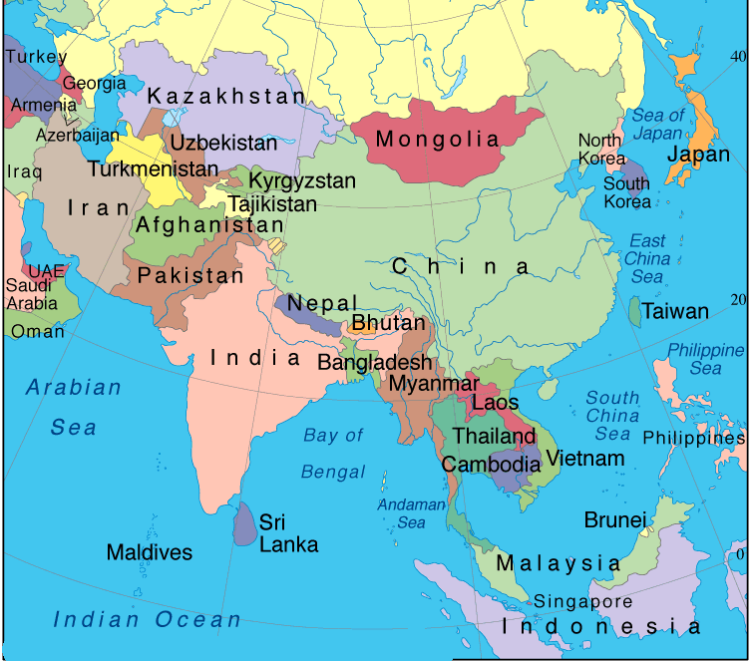
CHINA

Pros & Cons of The Three Gorges Dam
The creation of the Three Gorges Dam has been surrounded by controversy, because of the significant environmental and social consequences of such a large hydroelectric dam in China. There are questions over whether the dam will generate enough electricity to make the environmental, social and financial costs worth it, especially because China has such substantial energy needs.
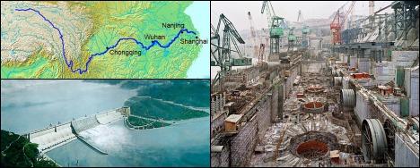From top, clockwise: location of the Yangtze River in China, construction on the Three Gorges Dam and the dam itself. China is the world’s factory and having the dam provides cheap, clean energy, which indirectly lowers the manufacturing cost as well. Not only China benefits, but the whole world as well.
China needs power
It has been suggested that there are more environmentally-friendly ways for China to meet its energy requirements and that; indeed, the dam could actually have a more detrimental impact on the environment than the alternatives. Thus, there are clearly some negatives associated with the Three Gorges Dam, so what are the positives?
Power output: equivalent to 18 nuclear power plants
In terms of energy production, the Three Gorges Dam does produce a significant amount of electricity, 18.2GW of electricity, which means that China doesn’t have to rely on fossil fuels, which are known to damage the environment and that are in short supply. Thus, China has put in place a sustainable source of energy that will continue to produce electricity even when there is no more oil left, which indicates that politicians have been thinking about China’s future energy requirements.
Renewable power
Plus, the dam could benefit the environment, because the energy produced comes from a renewable source and could reduce the amount of flooding that takes place in the surrounding area. The energy produced is also cleaner than that produced by burning coal and oil.
Tourist dollars and powering the economy
The dam could also be good for China’s economy, since the Three Gorges Dam has become a tourist site and the river has become more navigable, as it has been widened to allow ships and boats to pass through easily. Plus, energy is obviously crucial for the economic development of any country and so it is clear that the creation of this dam means that at least some of China’s energy requirements will be met, which will benefit their economy.
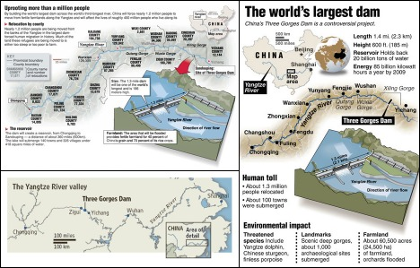Lets have a look at the cost from the environmental and human aspect: Over 60 thousand acres of farmland submerged, more than a thousand archeological sites lost forever, 1.3 million people relocated, more than 100 towns gone and countless threaten animal species, which includes the Yangtze dolphins. Looks like the cost of the dam is more than what was stated.
Environmental impact
However, many people have been displaced by the creation of the Three Gorges Dam, which clearly hasn’t benefited them. They have not been able to access the financial benefits of the dam, as they have been forced to move without fair compensation. Plus, the environmental benefits of this dam may have been overstated and the dam could actually cause problems, damaging the water quality and killing river life, causing landslides and submerging mines.
Energy efficiency
In terms of meeting China’s energy needs, the dam may not do very much, since China has taken a very inefficient approach to energy production. Plus, the dam, as with other sources of energy, is designed to meet the energy needs of the urban population and so, as always, the rural population loses out.
The dam
Clearly, then, there are significant pros and cons associated with the Three Gorges Dam, but there is not much that can be done about it now.

